Brighton Energy Co-op – Member survey results 2021
DRAFT REPORT - PREPARED FOR Power to Change
Power to Change/Brighton Energy Co-op

Brighton Energy Co-op – Member survey results

FOR DIRECT ENQUIRIES ABOUT THIS REPORT:
Mary Anderson
www.cagconsultants.co.uk
Partner
CAG CONSULTANTS

Mob: 07896 532194
Email: ma@cagconsult.co.uk

TO CONTACT CAG CONSULTANTS:
CAG CONSULTANTS
150 Minories
London EC3N 1LS

Tel: 020 8555 6126
Fax: 020 7900 1868

hq@cagconsult.co.uk
www.cagconsultants.co.uk

CONTENTS
1 Introduction 4
2 Respondent profile 5
3 Motivations for involvement in Brighton Energy Co-op 7
4 Changes made because of involvement in Brighton Energy Co-op 9
5 Priorities for future work 12
6 Investment intentions 13
7 Engaging members 14
8 Volunteering for Brighton Energy Co-op 15
Appendix – Survey questions 16

Introduction
In 2019 CAG Consultants, in partnership with Fiveways, were commissioned to conduct a three-year evaluation of the Power to Change Next Generation programme. One of the outputs from the first year’s work was a draft survey for the members, supporters, staff and volunteers of Community Energy companies aimed at understanding the impact of being involved in a Community Energy group – i.e., to determine what secondary impacts or changes flow from people’s involvement.
In late May/early June 2021 Brighton Energy Co-op allowed us to pilot the survey amongst their members. This report highlights the results of that survey (which is included as an appendix).

Method
- The survey was conducted online. Brighton Energy Co-op circulated the customised survey link (prepared by CAG/Fiveways) to 475 members via email. A reminder email was not sent due to concerns about over-contacting people.
- The survey routed respondents according to their relationship with Brighton Energy Co-op. Typically, each respondent answered around 20 questions which, on average took 9 minutes to complete (median = 6 minutes, mode = 5 minutes).
- The survey did not collect any personal data.
- No incentive was offered for completing the survey – members were told that Brighton Energy Co-op would report back the results.

Respondent profile
- 79 people responded to the survey between 28th May and 8th June 2021. This represented a 16% response rate for the 475 members sent the survey.

Involvement in Brighton Energy Co-op
- 93% of respondents described themselves as “an investor member”
- 6% were board members

Link with Brighton
- 42% of respondents (79) live in Brighton or the Brighton and Hove area
- 22% lived in another part of Sussex
- 25% said that they had no connection with the area.

Involvement in other Community Energy Groups
- For 62% of respondents (79) Brighton Energy Co-op was the first community energy group they have been involved in.
- The 38% of respondents who had been involved in other groups mentioned their connections to a variety of groups. Those mentioned twice or more were; Small Wind, Bath and West CE, BHESCO, Ferry Farm Solar, High Winds, Low Carbon Hub (Oxford), Lynton Hydro, OVESCO, Repower Balcombe, Stockport Hydro, Thrive, Energy4All and Triodos Crowdfunding.

Age
- 19% of respondents (53) were over 70, 62% were over 50.

Ethnicity
- 98% of respondents who gave their ethnicity (51) were White/White British.

Personal income level
- Of the 44 respondents who indicated a personal income level, 52% had an annual personal income level of £25,000 or less, 23% had an income of £50,000 or more.

Motivations for involvement in Brighton Energy Co-op
Motivations for members getting involved in Brighton Energy Co-op are shown on p8. Key findings on respondents’ motivations are:
- The two most important reasons for getting involved in Brighton Energy Co-op are:
  - “to take action to tackle climate change” - 99% of respondents (78) thought this was “very important” or “important” – and
  - “to make my money align with my principles” - 92% of respondents (77) thought this was “very important” or “important”
- Two further reasons for getting involved in Brighton Energy Co-op are:
  - “to help provide funds for good causes” – 69% of respondents (77) thought this was “very important” or “important” - and
  - “to contribute to something that benefits the local area” – 66% of respondents (77) thought this was “very important” or “important”
- Getting an attractive return on investment was considered “important” or “very important” by 55% of respondents (74)
- Meeting others with similar interests was the least important of the options given – considered “important” or “very important” by 20% of respondents (75

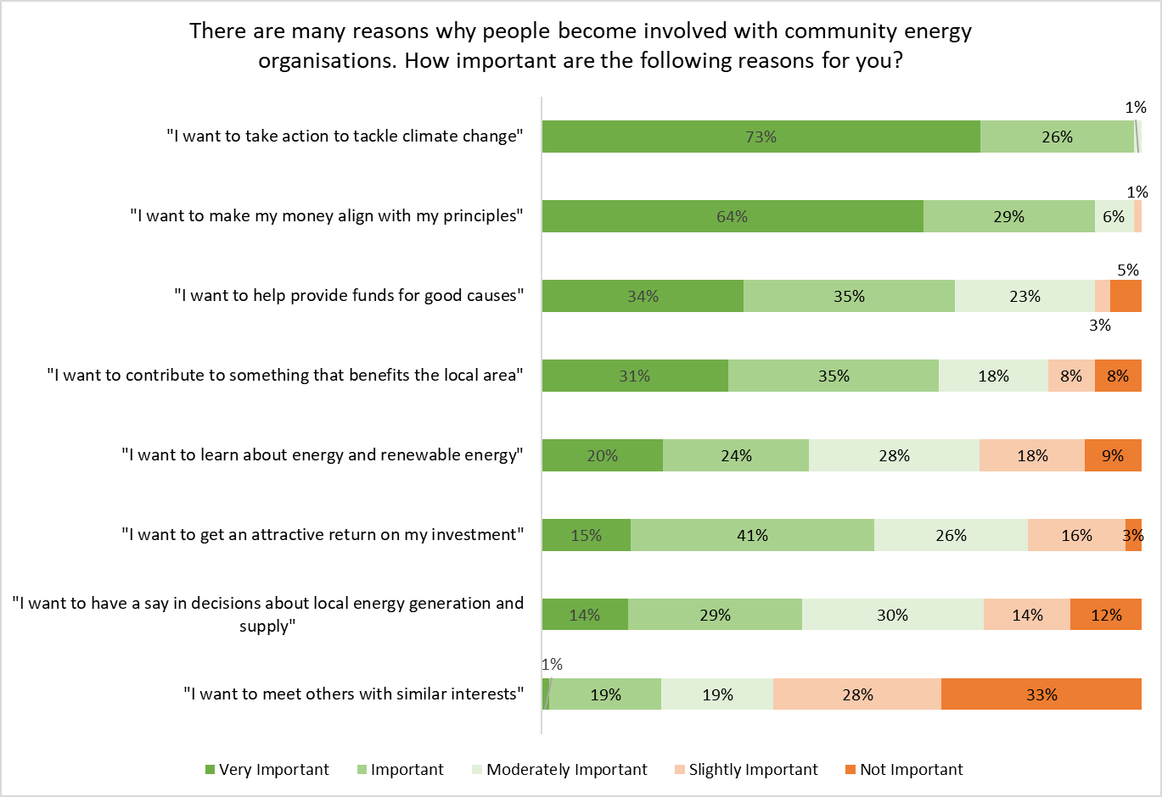

Changes made because of involvement in Brighton Energy Co-op
This section considers whether involvement in Brighton Energy Co-op influenced people’s behaviour, and if so how. Key findings, shown in the chart on p10, were that:
- The most common changes reported by respondents are increased knowledge about renewable energy (52% agree, 16% disagree) and feeling able to influence decisions of Brighton Energy Co-op (37% agree, 14% disagree); and
- 47% of respondents agree they have made changes to reduce their personal carbon footprint because of their involvement with BEC, although 33% disagree.
- The least common changes are learning new things about energy efficiency (26% agree, 23% disagree) and having influenced decisions that have directly saved carbon (24% agree and 38% disagree) – this is despite feeling able to influence Brighton Energy Co-op decisions (see first bullet point above).

Energy efficiency actions

Respondents were asked about a range of actions individuals could take with regards to energy efficiency.
- 27 respondents had not changed all their lighting to LED bulbs and fittings before their involvement with Brighton Energy Co-op – 52% of these had done so since their involvement with BEC, and a further 11% were considering it since their involvement
- 42 respondents had not installed wall or floor insulation before their involvement with Brighton Energy Co-op – 21% of these had done so since their involvement with BEC and a further 10% were considering it since their involvement
- Involvement with Brighton Energy Co-op had not (as yet) prompted action amongst those who had not previously installed a heat pump (75 – none had done so since their involvement), installed solar thermal panels (60 – 2% had done so since) or installed an EV charging point (69 – 6% had done so since). However since their involvement 17% of respondents who had not previously done so, were considering installing a heat pump and 22% were considering installing an EV charging point.

 | Number who had not already taken this step | % taken action since being involved with Brighton Energy Co-op | % considering  since being involved with Brighton Energy Co-op
Installed solar pv panels | 48 | 8% | 13%
Installed solar thermal panels | 60 | 2% | 5%
Installed wall or floor insulation | 42 | 21% | 10%
Installed a heat pump | 75 | 0% | 17%
Installed an EV charging point | 69 | 6% | 22%
Changed all your lighting to LED bulbs/fittings | 27 | 52% | 11%

- Other actions taken included lifestyle changes to reduce energy usage (mentioned by 6 respondents), glazing or insulations (5), storing or diverting energy from PV (3) and purchasing an EV vehicle (3).
- Two respondents cited renting as the reason for not taking more action.

Priorities for future work
Respondents (74) were asked to rank five renewable energy solutions six that Brighton Energy Co-op had previously shared in their three-year strategy in terms of which they would like to see Brighton Energy Co-op focusing on going forward.
- Roof top solar PV was the clear priority amongst members, with on shore wind ranked fifth out of five.
 | Average rank | Overall Rank
Installation of more roof top solar PV projects | 0.96 | 1
Investment in energy storage (battery) projects | 1.82 | 2
Installation of a solar farm of 5 to 10 MWs | 2.14 | 3
Installation of EV charging points connected to our solar PV | 2.42 | 4
Investment in local onshore wind projects | 2.66 | 5
- When asked about other priorities no clear picture emerges with the following activities mentioned three times or more: hydro-electricity generation supporting householders with energy efficiency measures, and other forms of energy storage.

Investment intentions
The survey asked respondents about their investment intentions. The findings were:
- 79% of respondents (76) answered “yes” to “Assuming the bank base rate remains very low, would you be prepared to purchase shares in Brighton Energy Co-op in the future?”.
- Of those who said no (5) two were elderly and simplifying their finances and two were investing in other things to spread risk.
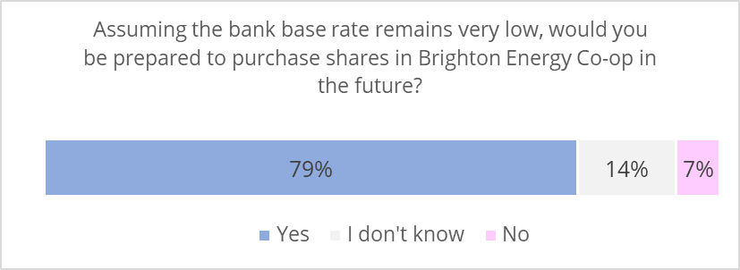
- Of those who would be prepared to purchase shares when the bank base rate is low (56), 80% would be prepared to purchase shares with a return of 3-4%.
Suggested rate of return | Percent agreeing
1% | 2%
2% | 13%
3% | 41%
4% | 39%
5% | 5%
- Of the 60 respondents who answered – 3% would be prepared to waiver the annual interest on their investment and donate it to the community benefit fund, 37% would not, and 47% answered “possibly”.

Engaging members
As we have seen earlier, there is an appetite for more investment in Brighton Energy Co-op activity. 37% of respondents (73) had already invested in another carbon reduction project, and a further 48% would be interested in doing so.
There was also considerable interest in assisting a director with a specific project (39% would be interested in this in the future) or assisting with a specific skill or area of expertise on an “as required” basis (36% would be interested in this in the future).
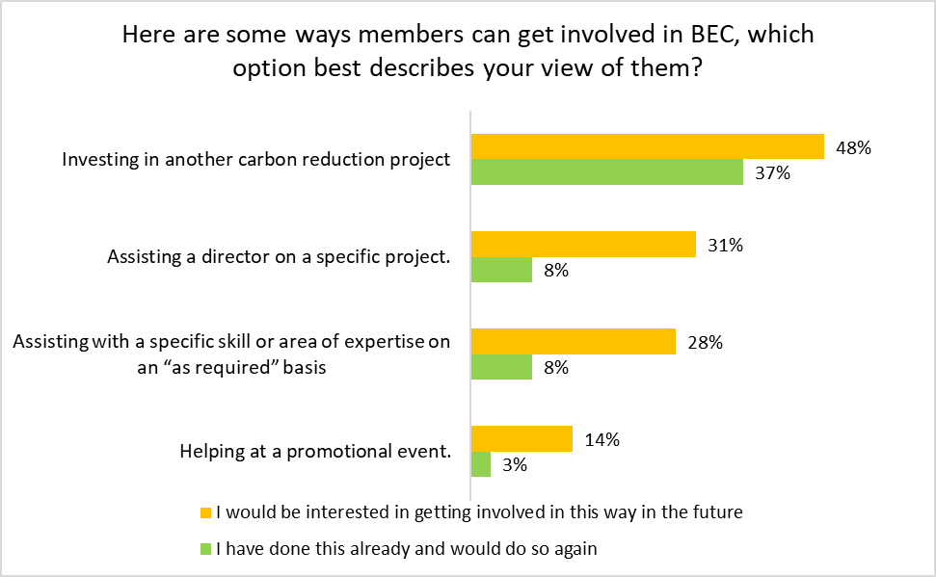

Volunteering for Brighton Energy Co-op
Additional questions were asked of board members (3 respondents).
None of these respondents (3) agreed that volunteering their time for Brighton Energy Co-op helped them to gain employment or to progress, or change, their career.
Other benefits of involvement include “putting something back” that will have a long-term and local benefit, and meeting new friends.

Appendix – Survey questions
Thank you for opening our survey

At Brighton Energy Co-op we are keen to understand the impact of our work. We would we very grateful if you could complete this survey.
There are 10 questions. Many of these are quick "multiple choice" ones, so the survey can be completed in 5-10 minutes.
We are not collecting any identifying information so your answers will be anonymous.
If you have any questions or would like any more information, please contact Atlanta Cook on atlanta@brightonenergy.org.uk
Thank you for your support.
Brighton Energy Co-op

- Was Brighton Energy Co-op the first Community Energy Company you have been involved with?
- Yes
- No
If no, please tell us which other Community Energy Companies you have been involved with? [free text]

- Brighton Energy Ltd aims to benefit people living or working in Brighton & Hove and the surrounding area. Which of the following best describes your connection to the area?
I live in Brighton
I live in the Brighton & Hove area
I live in another part of East Sussex
I live elsewhere, but work in the Brighton & Hove area
I have no connection with this area
I have another connection to this area (please tell us)

- There are many reasons why people become involved with community energy organisations. How important are the following reasons for you?
- I want to learn about energy and renewable energy
- I want to take action to tackle climate change
- I want to help provide funds for good causes
- I want to have a say in decisions about local energy generation and supply
- I want to contribute to something that benefits the local area
- I want to get an attractive return on my investment
- I want to make my money align with my principles
- I want to meet others with similar interests
Answer options
Very Important
Important
Moderately Important
Slightly Important
Not Important

If you had any other reasons for becoming involved in community energy, please add them here: [free text]

- Thinking back since you got involved with Brighton Energy Co-op what extent do you agree or disagree with the following statements.
“As I result of my involvement with Brighton Energy Co-op …
- I have learnt new things about renewable energy
- I have learnt new things about energy efficiency
- I have learnt new things about climate change
- I have learnt new things about how to get to 'net zero' carbon
- I have learnt new things about other aspects of sustainability
- I have made changes in my life to reduce my own carbon footprint
- I have got involved in other sustainable energy initiatives
- I feel able to influence decisions made by Brighton Energy Co-op
- I have influenced decisions by Brighton Energy Co-op which have directly saved carbon

Answer options
Definitely agree
Tend to agree
Neither agree nor disagree
Tend to disagree
Definitely disagree
I don’t know

- Here are some energy efficiency measures people can take in their homes. Which statement best reflects where you are in relation to these measures?

- Installed solar pv panels
- Installed solar thermal panels
- Installed wall or floor insulation
- Installed a heat pump
- Installed an EV charging point
- Changed all your lighting to LED bulbs/fittings

Answer options
I had done this before my involvement with Brighton Energy Co-op
I have done this since I got involved with Brighton Energy Co-op
I was considering this before my involvement with Brighton Energy Co-op
I am considering this since I got involved with Brighton Energy Co-op
I am not considering this

If there are any other steps you have taken to be more energy efficient since your involvement with Brighton Energy Co-op please tell us here [free text]

- We shared our 3 Year Strategy with this survey which includes some of the renewable energy solutions that Brighton Energy Co-op could develop in the future. Thinking of what you would like to see BEC focus on going forward, how would you rank them?
With 1 being the activity you would most like to see BEC focus on and 5 being the activity you would least like to see BEC focus on. When you select a number from the drop-down list the options will automatically order themselves.

Installation of more roof top solar PV projects
Installation of a solar farm of 5 to 10 MWs
Installation of EV charging points connected to our solar PV
Investment in local onshore wind projects
Investment in energy storage (battery) projects
If there is any other activity you would like to see BEC focusing on in the future, please let us know here [free text]

- Here are some ways members can get involved in BEC, which option best describes your view of them?
Helping at a promotional event
Assisting with a specific skill or area of expertise on an “as required” basis
Assisting a director on a specific project
Investing in another carbon reduction project

Answer options
I have done this already and would do so again
I have done this already and wouldn’t do so again
I would be interested in getting involved in this way in the future
I wouldn’t be interested in getting involved in this way in the future

- Assuming the bank base rate remains very low, would you be prepared to purchase shares in Brighton Energy Co-op in the future?
Yes (to 9)
No (to 11)
I don’t know (to 11)
- Assuming the bank base rate remains very low, what interest rate would you be prepared to purchase shares in BEC in the future?
1%
2%
3%
4%
Other, please state

- Would you be prepared to waiver the annual interest on your investment and donate it to the BEC Community Fund?
Yes
No
Possibly
I don’t know

- Which of the following best describes your involvement with Brighton Energy Ltd (BEC)?
a board member (To 12)
an investor member (To 15)
a paid member of staff (To 15)
a volunteer (To 12)
a supporter (To 15)
a subscriber to the newsletter (To 15)
a recipient of help or information from Brighton Energy Co-op (To 15)
a representative of a site where BEC has installed solar PV (To 15)
I am not involved (To 15)
Other (please tell us) (To 15)

- Has volunteering for Brighton Energy Co-op helped you to gain employment or to progress or change your career?
- Yes (to 13)
- No (to 14)
- I don’t know (to 14)

- Please explain what difference volunteering for Brighton Energy Co-op made to help you to gain employment or to progress or change your career? [free text]

- Please tell us about any other benefits volunteering for Brighton Energy Co-op has brought you. [free text]

Thank you for your feedback. We would be very grateful if you could tell us more about yourself. These questions are optional, we ask them in order to measure how well we are reaching a diverse audience. Please be assured that all your responses to this survey will be anonymous, we are not collecting any identifiable information.
- How old are you?
- under 18
- 18-29
- 30-49
- 50-69
- 70+
- Prefer not to say

- Which of the following best describes your ethnicity?
- Asian/Asian British
- Black/African/Caribbean/Black British
- Mixed/Multiple ethnic groups
- White/ White British
- Other ethnic group (please tell us)
- Prefer not to say

- Which of the following best describes your personal income last year?
- £1 to £9, 999
- £10, 000 to £24, 999
- £25, 000 to £49, 999
- £50, 000 to £74, 999
- £75, 000 to £99, 999
- £100, 000 or more
- Prefer not to say

Thank you for your time and input. Your feedback will help Brighton Energy Co-op understand our impact and improve our service for members.

CAG Consultants is an employee-owned co-operative with more than 30 years’ experience of high-quality research and evaluation on economic, social and environmental issues, with particular expertise on evaluation and sustainable energy. Fiveways have broad expertise in advising and evaluating the community and voluntary sector, including governance and diversity issues.
Not every respondent answers every question. Numbers in brackets represent the number of respondents that answered the question.
These proportions may not add up to 100% as answer options also included “neither agree nor disagree” and “I don’t know”.

